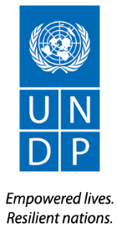

Ref: UNDP/30/07/2026
Dear [Name of donor signatory in the cost sharing agreement],

Subject: Entrepreneurship and Mentorship Opportunities for Women's Economic Resilience (EMPOWER) Project Final Report

Reference is made to the contribution agreement between the Government of France and UNDP for the project Entrepreneurship and Mentorship Opportunities for Women's Economic Resilience (EMPOWER), which has been effective since 1 September 2024.

I am pleased to submit herewith the Final Report for the abovementioned project.

The report summarizes the progress of the project between 1 September 2024 and 28 February 2026 and provides an overview of the achievements, challenges, lessons learned, and final financial status.

I thank the Government of France for its generous contributions to UNDP and look forward to strengthening our partnership in support of development in Türkiye in the future.

<Signature>
[Name of UNDP signatory in the agreement]
[Title of UNDP signatory in the agreement]
UNDP Türkiye Office

Attached:
Entrepreneurship and Mentorship Opportunities for Women's Economic Resilience (EMPOWER) Project Final Report

[Name of donor signatory in the agreement]
[Title of the donor signatory in the agreement]
[Donor institution name]
[City, country]

Reporting Period | 1 September 2024 – 28 February 2026
Donor | Government of France
Country | Türkiye
Project Title | Entrepreneurship and Mentorship Opportunities for Women's Economic Resilience (EMPOWER) Project
Project Locations | Kahramanmaraş
Project ID  (QUANTUM Project ID)  Strategic Plan and/or CPD Outcomes | 01003183  Outcome 1.2: By 2030, women and girls have improved and equal access to resources, opportunities and rights, and enjoy a life without violence and discrimination.  Output 1.2: Access to resources, digital opportunities, skill formation, and decent jobs improved in urban and rural settings.Output 2.3: Resilient market infrastructure enhanced, access to financial and non-financial assets expanded, and livelihoods improved to accelerate rural development.
Implementing Partner(s) | Kahramanmaraş Chamber of Commerce (KMTSO)
Project Start Date | 1 September 2024
Project End Date | 28 February 2026
LPAC Date | NA
Steering Committee/Project Board Meeting Dates | NA
SDG linkages | TARGET_8.3- Promote development-oriented policies that support productive activities, decent job creation, entrepreneurship, creativity and innovation, and encourage the formalization and growth of micro-, small- and medium-sized enterprises, including through access to financial services.  TARGET_5.A- Undertake reforms to give women equal rights to economic resources, as well as access to ownership and control over land and other forms of property, financial services, inheritance and natural resources, in accordance with national laws.
GEN marker | GEN 3
2025 Delivery to Budget Ratio | 100%
2024-2025 Work Plan Budget | USD 750,000
Total resources required
Revenue received | Donor  Gov. of French USD 750.000,00  Total USD 750,000
Unfunded budget | USD
UNDP Contact Person | Cem Bayrak  Portfolio Manager  UNDP Türkiye  Email: cem.bayrak@undp.org  Tel.: +905413879928

Executive Summary

The "Entrepreneurship and Mentorship Opportunities for Women's Economic Resilience (EMPOWER) Project" was implemented between 1 September 2024 and 28 February 2026 in the earthquake-affected province of Kahramanmaraş. The project was designed to address the severe socio-economic impacts of the February 2023 earthquakes, which disproportionately affected women entrepreneurs, destroying businesses and disrupting livelihoods. EMPOWER aimed to establish a vibrant and inclusive environment to support the advancement of women entrepreneurs, concurrently fostering strong social networks and breaking down structural barriers to their economic empowerment.
The project successfully focused on a single primary outcome: the establishment and operationalization of the Women's Business Development Centre (KİGEM) in Kahramanmaraş. KİGEM was created as a holistic support mechanism combining physical infrastructure, capacity development, and mentorship services to serve as a catalyst for women's economic resilience in the region.
Building upon strong local partnerships, particularly with the Kahramanmaraş Chamber of Commerce and Industry (KMTSO) and İhtiyaç Haritası (Needs Map), the project achieved significant results under Output 1. Establishment of the Women's Business Development Centre in Kahramanmaraş:
- Established KİGEM: A fully operational entrepreneurship hub was established within a repurposed container settlement, providing low-cost workshop spaces, office and IT infrastructure, and common-use facilities.
- Developed a Sustainable Business Model: A comprehensive Business Model and Capacity Development Action Plan was created to guide KİGEM's strategic development, financial sustainability, and operational framework, ensuring its long-term viability and replicability.
- Empowered Women Entrepreneurs: 15 women entrepreneurs were onboarded as the first cohort at KİGEM, operating their businesses from the centre and benefiting from its facilities. An additional 99 women entrepreneurs (a total of 114) received capacity development support through a mix of in-person and online training.
- Delivered Impactful Mentorship: A structured mentorship programme provided 200 hours of one-on-one support to 20 women entrepreneurs, focusing on sales, marketing, and e-commerce strategies, achieving a 100% completion rate and 92% satisfaction level.
- Enhanced Market Access and Visibility: A wide range of visibility, networking, and market access activities were implemented, including participation in national fairs (IFCO, Craft Istanbul), local festivals, and high-level international visits. A dedicated sales and exhibition outlet was also established in early 2026 to provide a direct retail platform for KİGEM entrepreneurs.
By addressing both the immediate physical needs for workspace and the long-term needs for skills development, mentorship, and market linkages for the earthquake victim women entrepreneurs the EMPOWER project has successfully contributed to the social and economic recovery of Kahramanmaraş. KİGEM has emerged as a key institutional platform supporting women-led businesses, with strong potential for replication in other post-disaster or post-crisis contexts.

Background Information
The earthquakes in southern Türkiye on 6 February 2023 and the days that followed killed at least 50,700 people and destroyed more than 313,000 buildings. They left 3.3 million people homeless across 11 provinces with a territory of 110,000 sq km and a population of 15.6 million (including half of the 3.7 million Syrians enjoying temporary protection in the country). Six months later, 2.6 million people are still living in tents and other temporary shelters, most with only rudimentary services.
The financial cost of the earthquakes was estimated at US$103.6 billion in the Türkiye Earthquakes Recovery and Reconstruction Assessment (TERRA), a post-disaster needs assessment led by UNDP. This was an early and conservative estimate that accounted only for damages and losses. The costs of reconstruction, particularly if done in the spirit of “build back better,” will be far higher. There are 3.8 million employed persons in the disaster region and the share of regional employment in national employment is 13.3%. Informal employment across the disaster region is around 39%. The damage incurred by the private sector except housing is estimated at 222.4 billion TRY (11.8 billion USD). Further, the total financial burden of the earthquake disaster for the country is 2 trillion TRY (103.6 billion USD), which is equal to 9% of GDP forecast for 2023.
The earthquake has brought about a myriad of challenges for entrepreneurs as well. In regions such as Hatay, Kahramanmaraş, Adıyaman, and Malatya, over half of businesses have suffered severe damage, with more than 90% experiencing negative economic impacts. It is estimated that 220,000 businesses are severely damaged and in need of demolition.
Even one and a half years after the earthquake, the severe effects on social life and livelihoods persist. The UNDP, with generous funding from its donors and collaboration with local actors, has implemented various projects and activities aimed at building sustainable models, particularly focusing on the social and economic recovery of the region. However, additional resources are imperative to establish new structures that can serve as catalysts for the improvement of social life and entrepreneurship in the affected region.
UNDP’s early recovery response focuses on four areas:
- Restoring care services for vulnerable groups
- Improving management of waste and earthquake debris
- Restoring livelihoods and reviving business activity
- Protecting endangered cultural heritage
This proposed initiative Entrepreneurship and Mentorship Opportunities for Women’s Economic Resilience aims to establish a vibrant and inclusive environment that supports the advancement of women entrepreneurs, concurrently fostering strong social networks. This overarching objective is motivated by a dedication to breaking down barriers and advocating for gender equality in the entrepreneurial sphere, promoting economic empowerment, and nurturing collaborative relationships among women with a notion of alleviation the childcare burden of women by providing/directing them to the facilities.
The Empowering Women Entrepreneurship Project focuses on a single primary outcome: Establishment of the Women's Business Development Centre in Kahramanmaraş through supportive activities like capacity development for women entrepreneurs and enhancing market accessibility

Progress Review
Output 1 – Establishment of Women’s Business Development Centre
The EMPOWER Project (Entrepreneurship and Mentorship Opportunities for Women’s Economic Resilience), funded by the Government of France and implemented by UNDP Türkiye, aimed to establish a structured, inclusive and sustainable ecosystem to support women entrepreneurs in the earthquake-affected province of Kahramanmaraş. The Project directly contributed to restoring livelihoods, enhancing women’s economic participation, and fostering resilience through the establishment and operationalization of the Women’s Business Development Centre (KİGEM).
Building on post-earthquake recovery needs, the project focused on addressing structural barriers faced by women entrepreneurs, including limited access to finance, markets, networks, and business development services. Through a combination of physical infrastructure, capacity development, and mentorship support, EMPOWER created a holistic support mechanism tailored to both early-stage and existing women-led businesses.
The key achievements and activities under this output include:
Design and Modeling of the Centre (Activity 1):
KİGEM was designed as a joint initiative between the Kahramanmaraş Chamber of Commerce and Industry (KMTSO) and UNDP.
The centre was realized by transforming a container settlement previously established by Needs Map (İhtiyaç Haritası) to provide low-cost workshops and shared collaborative spaces.
Development of the Business Model and Operational Framework (Activity 2):
To ensure the long-term sustainability of the facility, a comprehensive Business Model and Capacity Building Action Plan was developed.
This plan defines the centre's services, target demographics, revenue streams, and strategic partnerships, establishing KİGEM as a replicable model for post-earthquake economic recovery.
Establishment and Operationalization of KİGEM (Activity 3):
The centre was officially inaugurated on January 15, 2025, fully equipped with all necessary infrastructure, including office furniture, production equipment, and IT hardware.
15 women entrepreneurs launched their operations within the centre.
To enable entrepreneurs to reach customers directly, an additional sales and exhibition store was opened in a central location in Kahramanmaraş in early 2026.
Capacity Building and Mentorship Support (Activity 4):
A total of 114 women entrepreneurs received face-to-face and online training in critical areas such as e-commerce, digital marketing, business development, and financial literacy.
Through mentorship program, 20 women entrepreneurs were provided with 200 hours of one-on-one mentoring. The program concluded with a 100% completion rate and a 92% satisfaction rate.
To further enhance market access, entrepreneurs were supported to participate in national trade fairs (e.g., IFCO, Craft Istanbul), local festivals, and B2B networking events.
Activity 1: Design and Modelling of the Centre
Under this activity, the Women’s Entrepreneurship Center (KİGEM) was designed as a joint initiative of the Kahramanmaraş Chamber of Commerce and Industry (KMTSO) and UNDP. The centre was established within a post-earthquake container settlement area originally developed by İhtiyaç Haritası (Needs Map), which was redesigned and repurposed into a dedicated entrepreneurship hub. A space allocation agreement between KMTSO and Needs Map was signed on 16 July 2024, positioning Needs Map as a key project partner.
Immediately following the launch of the EMPOWER Project in September 2024, the design and modelling process for KİGEM was initiated as one of the first implementation activities. The design work was carried out on an accelerated schedule during September and October 2024 in close coordination with KMTSO, enabling the project to move rapidly from conceptual planning to physical implementation. During this period, the existing structure and available spaces were assessed, the functional layout of the centre was determined, and the necessary architectural and interior design arrangements were developed in line with the operational needs of women entrepreneurs.
Following the completion of the main design and modelling works by the end of October 2024, implementation moved directly into the refurbishment, interior decoration and furnishing phase. The existing premises were adapted to accommodate individual production/workshop spaces, shared working areas, training and meeting facilities, and common areas. These works, together with the installation of the necessary furnishings and equipment, were carried out during the final months of 2024, preparing the centre for its operational launch in January 2025.
The design focused on creating a functional and inclusive environment providing low-cost workshop spaces, shared facilities and integrated services such as training, mentorship and consultancy. This approach enabled women entrepreneurs engaged in production-based activities to re-establish and develop their businesses, while ensuring that KİGEM operates as both a workspace and a comprehensive business development platform.
The pictures below illustrate the status of the site before and after the Project.
Before the Project:
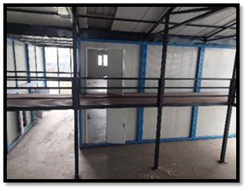
Figure 1: Container Settlement Area for KIGEM
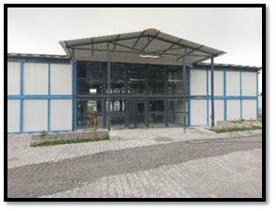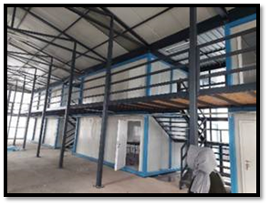
Figure 2: Container Settlement Area for KIGEM Figure 3: Container Settlement Area for KIGEM
After the Project:
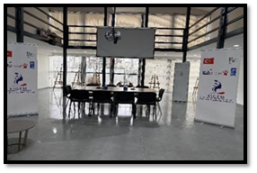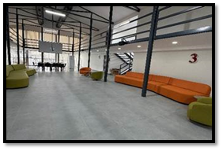
Figure 4: KIGEM Figure 5: KIGEM
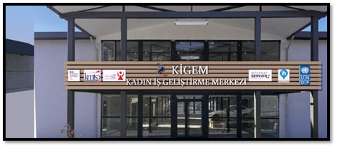
Figure 6: KIGEM
Activity 2: Development of Business Model and Operational Framework
Under this activity, a comprehensive Business Model and Capacity Development Action Plan was developed to guide the strategic and operational development of KİGEM as a sustainable and impact-driven women’s entrepreneurship hub. The plan was finalized in September 2025, providing KİGEM with a comprehensive strategic and operational roadmap for its continued development and long-term sustainability. The plan defines the centre’s core business model through a Business Model Canvas, outlining its value proposition, target groups, service delivery mechanisms and partnerships, while emphasizing affordable production spaces, capacity development services, e-commerce integration and diversified revenue streams. It also establishes a structured capacity development and operational framework covering training, mentorship, institutional governance, digital transformation and monitoring systems. In addition, the plan introduces incubation programmes, modular training structures and stakeholder engagement mechanisms. Supported by performance tracking tools such as KPIs, log-frames and implementation timelines, the framework ensures effective monitoring, sustainability and scalability, positioning KİGEM as a replicable model for women’s entrepreneurship in post-earthquake recovery contexts. The Business Model and Capacity Development Action Plan is provided in Annex 2 of this Final Report.
Activity 3: Establishment and Activation of KİGEM
Under this activity, the centre was officially launched on 15 January 2025 in partnership with the Kahramanmaraş Chamber of Commerce and Industry (KMTSO). All necessary infrastructure and equipment were procured and installed, enabling full operational capacity. This included office and workspace furnishings, production-oriented equipment tailored to different sectors, IT and digital infrastructure, as well as common-use facilities such as meeting areas and training spaces. These investments ensured that women entrepreneurs could operate in a functional, well-equipped, and collaborative environment from the outset. While the majority of expenditures under this activity were incurred during the initial phase, prior to the official opening of the centre, some additional expenditures were made periodically throughout 2025 to address operational and emerging needs.
KİGEM Establishment Costs (Activity 3)
Cost Description | USD
Service Cost - Construction and Engineer | 268,703.26
Machinery and Equipment | 116,413.23
Furniture | 8,838.70
Total | 393,955.19

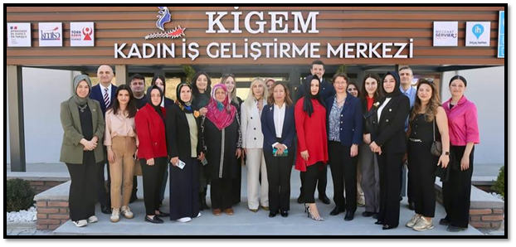Figure 7: Field Visit to KIGEM
KİGEM began functioning as an incubation and business development hub, offering shared workspace, training, mentoring and networking opportunities. Initially, 14 women entrepreneurs were onboarded and started operating their businesses within the centre, benefiting from both physical facilities and structured support services. In September 2025, one additional woman entrepreneur joined KİGEM and commenced her business activities, bringing the total number of women entrepreneurs operating within the centre to 15.
Sectors of Entrepreneurs
Entrepreneur | Company | Sector
Tuba Düşünceli | Gelincik Tasarım | Home textile products
Hazel G. Yürürdurmaz | Hey Atelier Kids Fashion | 0-10 years clothing
Betül Firat | Tofema Eğitici Ahşap Oyuncak | Toys
Yasemin Yüksel | Yasemin Yüksel Dikim Atölyesi | Home textile products
Makbule Palta | M_Butik | Design-tailoring
Hatice Saçmalı | Azkar Hediyelik Eşya | Gift items (walnut carving)
Yaren Özçelebi | June Art Gallery | Graphic, printing, design
Yasemin Iskender | Yasemin İskender Atelier | Design-tailoring
Selda Bayazit | Ab-ı Hayat Tılsımlı Gömlek | Gift items
Eylül Duran | Sette Art Design | 3D Gift items
Nuray Taşkıran | Maraş Koza El Sanatları | Gift items (walnut carving, silkworm cocoon)
Kübra Kirişçi | NSK Textile&Boutique | Gift items (punch embroidery)
Gülnur Beyit | Gurgum Concept | Gift items, home textiles
Ayşe Yılmaz Koca | N.ART STUDIO | Ceramics
Tuğba Kuş | Küçük İlham Atölyesi | Ceramics
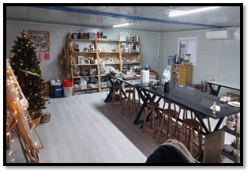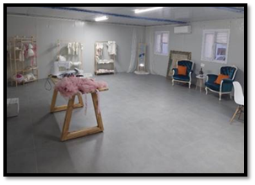
Figure 8: KIGEM Figure 9: KIGEM
To further strengthen market access and visibility of women-led businesses, an additional sales and exhibition outlet was established in early 2026 in a central and highly visible location in Kahramanmaraş. This approximately 60 m² retail space enables KİGEM entrepreneurs to collectively showcase and sell their products, providing a direct interface with customers and enhancing commercial opportunities. The store complements the centre’s incubation and capacity development services by supporting product commercialization, branding and customer engagement.
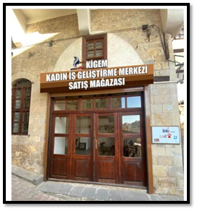
Figure 10: KIGEM sales and exhibition outlet
Activity 4: Capacity Development and Mentorship Support
A comprehensive capacity development programme was implemented, reaching a total of 114 women entrepreneurs (revised official figure). The programme included both in-person and online components to ensure accessibility, including outreach to rural areas.
Key capacity development areas included:
- E-commerce and digital transformation
- Sales and marketing strategies
- Business development and management
- Financial literacy and pricing strategies

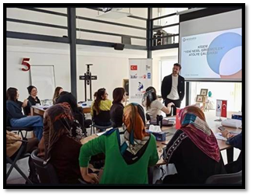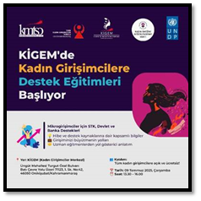
Figure 11: Capacity Development Programme (CDP) Figure 12: Announcement of CDP
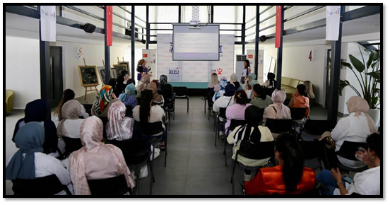
Figure 13: Capacity Development Programme
A structured mentorship programme was delivered, totalling 200 hours of one-on-one mentoring, with each participant receiving individualized support.
The mentorship was organized around four core modules:
- Sales and Marketing Fundamentals
- E-commerce Strategies
- Digital Marketing
- Sales Channel Development
A total of 20 women entrepreneurs actively participated in the intensive mentorship programme, achieving a 100% completion rate and 92% satisfaction level. Supporting documentation verifying participation and completion, together with the relevant participant satisfaction assessment records, is provided in Annex 4 of this Final Report.

As a result:
- Many participants launched new e-commerce channels (e.g., marketplaces and social commerce platforms)
- Existing businesses restructured their digital sales strategies
- Entrepreneurs improved branding, customer engagement, and market positioning
- Digital visibility and sales performance significantly increased
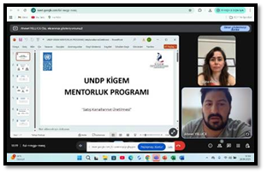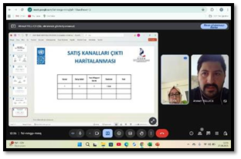
Figure 14: Mentorship Session Figure 15: Mentorship Session
In addition to training and mentorship activities, KİGEM implemented a wide range of visibility, networking and market access activities, including participation in national and local events, fairs and institutional programmes.
Key activities include:
15 January 2025: KİGEM official launch event with broad national media coverage
- 30 January 2025: Participation of all entrepreneurs in the Kahramanmaraş E-Export Summit
- 15 February 2025: Participation of 14 entrepreneurs in the Women’s Labour Shopping Festival (Piazza AVM)
- 25 February 2025: Participation in KOSGEB & JICA Women Entrepreneurs Meeting (panel contribution)
- 4 March 2025: Organization of the event “From Recovery to Resilience: Strengthening Women-Owned Businesses” (UNDP & KİGEM)
- 13 March 2025: High-level visit by the Ambassador of France and UNDP Resident Representative
- 18–20 April 2025: Participation in TOGEM-DER Cemre Bazaar
- 22 April 2025: Participation in Doğa College Festival (3 entrepreneurs with stands)
- 25 April 2025: Hosting of EBRD-supported Women Entrepreneurs Board Strategy Closing Meeting
- 29 May 2025: Organization of the KİGEM Shopping Garden Event with high visitor engagement
- 25 June 2025: Participation in Kahramanmaraş–Syria Regional Economic Cooperation Summit (B2B exposure)
- 9 July 2025: Hosting of KEDV Women Entrepreneurship Support Training Programme
- August 2025: Allocation of three shops to KİGEM entrepreneurs within KAFUM Festival (one-month sales opportunity)
- 20–22 August 2025: Participation in IFCO Istanbul Fashion Fair (with stand and accommodation support)
- 25 September 2025: Participation in Adana Contemporary Art Fair
- 3 October 2025: Participation in Craft Istanbul Fair (2 entrepreneurs)
- 6 October 2025: Hosting of KOSGEB Business Development Support Programme
- 16 October 2025: Award achievement at KASİAD Awards (Local Innovative Product Award)
- 18–19 October 2025: Participation in Vintage Festival (13 entrepreneurs with stands)
- 19 November 2025: Participation in Women Entrepreneurs Day event in Ankara (TOBB KGK)
These activities significantly contributed to increasing women entrepreneurs’ market access, strengthening their branding and visibility, and enabling direct sales opportunities. Participation in large-scale national events such as IFCO, Craft Istanbul and KAFUM strengthened integration into wider markets, while institutional collaborations and international engagements enhanced KİGEM’s positioning within the regional entrepreneurship ecosystem.
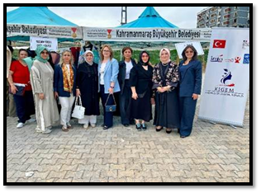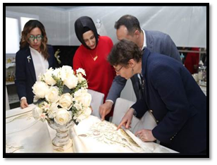
Figure 16: Participation to events Figure 17: Field visit to KIGEM

Contribution to Gender Equality
The EMPOWER project was designed under the GEN3 marker, ensuring that gender equality was the primary objective, not just a cross-cutting theme. The entire project was a direct intervention to address the structural barriers faced by women entrepreneurs in the earthquake-affected region.
A gender-responsive approach was applied across all activities:
- Dedicated Infrastructure and Services: The project established a centre specifically designed to cater to the needs of women entrepreneurs, providing a safe and supportive space for business development.
- Targeted Outreach: The project prioritized reaching women entrepreneurs, including those in rural areas, through online training and by providing support such as childcare arrangements (in collaboration with the Provincial Directorate of Family and Social Services and the Metropolitan Municipality) to ensure they could dedicate more time to their work.
- Strong Female Participation: Of the 114 women entrepreneurs who benefited from capacity development, all 114 were women, representing 100% of the target group. The 15 entrepreneurs operating from the centre were also women.
- Leadership and Empowerment: The mentorship programme and visibility activities were instrumental in building the confidence and business acumen of women entrepreneurs. The project empowered them to take on leadership roles in their businesses and community. The success of one entrepreneur, Nuray Taşkıran, who won the "Local Innovative Product Award" at the KASİAD Awards, is a testament to this empowerment.
By systematically mainstreaming gender and focusing on women's economic empowerment, the EMPOWER project has made a significant contribution to the long-term resilience and equality of women in Kahramanmaraş.

Indicator Based Performance Assessment

Description | Indicators | Baseline | Target  (End of project period) | Cumulative Realization | Explanation if there is significant deviation from the target
Output 1: Establishment of the Women's Business Development Centre (KİGEM) | 1.1. Number of Women's Entrepreneurship Centres Established. | 0 | 1 | 1 | Centre was established and officially launched on 15 January 2025, fully operational.
 | 1.2. Number of Model and Capacity Development Guideline/Plan prepared. | 0 | 1 | 1 | The Business Model and Capacity Development Action Plan was developed.
 | 1.3. Number of women entrepreneurs benefitting from the workplace of the centre. | 0 | 15 | 15 | The first cohort was onboarded, and all started operating their businesses at KİGEM.
 | 1.4. Sex-disaggregated number of persons benefitted from capacity development activities. | 0 | 100 | 114 | Exceeded the target. Total includes 100 women from the initial target and an additional 14. All 114 beneficiaries were women.

- Project Risks and Issues

Updated project risks and actions
Project Risk 1: There is a risk of not being able to include the individuals (beneficiaries) mostly in need of project supports due to lack of services for women who have to work in a daily job or women who have to take care of their children or women with disabilities.
- Cause: As a result of a lack of inclusiveness of the project design.
- Actions Taken:
  - UNDP instrumentalized its relations with local partners, including the Kahramanmaraş Chamber of Commerce and Industry (KMTSO), the Metropolitan Municipality, and relevant NGOs to closely engage and involve target groups.
  - Within the KİGEM centre, a dedicated library-style space was arranged for the children of the beneficiaries. This area provides a safe and suitable environment where children can do their daily homework and study while their mothers are engaged in training, mentorship, or production activities at the centre.
  - Beneficiaries with disabilities were supported by connecting them with the municipalities' "disability living centre" to receive necessary equipment and assessments, and the feasibility of building an elevator system for the centre was evaluated.
- Outcome: Mitigated. The provision of the dedicated children's study area directly addressed the childcare barrier for participating women. The project successfully reached and exceeded its target of 100 women entrepreneurs, reaching 114 participants. The support for children and accessibility ensured that the project was inclusive and responsive to the needs of women facing significant barriers.
Project Risk 2: There is a risk that project partner defects from its responsibilities related with project activities.
- Cause: As a result of low commitment at the project design and implementing phase.
- Actions Taken:
  - Protocols and a Responsible Party Agreement (RPA) were signed with KMTSO to ensure that local parties formally accepted their commitments and were accountable.
  - The responsibilities of KMTSO (e.g., covering management costs, long-term sustainability) and the roles of other partner İhtiyaç Haritası (providing the space) (involvement for sustainability) was clearly defined.
  - Regular coordination meetings were held to maintain engagement and monitor progress.
- Outcome: Resolved. KMTSO demonstrated strong commitment throughout the project, fulfilling its responsibilities for the establishment and operation of KİGEM, and has committed to its post-project sustainability.
Project Risk 3: There is a risk of incompliance with national laws and regulations during renovation (interior decoration of the centre) of the Women's Business Development Centre which might pose occupational health and safety concerns for workers of the contractors.
- Cause: As a result of incompliant contractor behaviour and lack of enforcement.
- Actions Taken:
  - Contracts with construction and renovation contractors explicitly included OHS standards and compliance with UNDP's and national laws and regulations.
  - UNDP's project management team supervised the renovation works and ensured that contractors adhered to the required safety protocols.
- Outcome: Mitigated. The interior decoration and renovation works were completed without any reported occupational health and safety incidents.
Project Risk 4: There is a risk of structural vulnerability in the temporary building where Women's Business Development Centre to be established.
- Cause: As a result of loose soil where the centre will be located, existence of active fault lines within the region, and due to poor design and insufficient ground surveys that cannot withstand recurring earthquakes in the region.
- Actions Taken:
  - The temporary building provided by İhtiyaç Haritası (Needs Map) was assessed based on its structural strength and its status was reviewed. Being a post-earthquake container settlement area, it had been designed with a specific focus on safety and resilience.
  - The building was further strengthened where necessary to ensure it could serve as a safe and functional workspace for the women entrepreneurs, taking into account the region's seismic risks.
- Outcome: Resolved. The structural integrity of the building was confirmed and strengthened as needed. The centre has been operating safely since its launch in January 2025.

Updated project issues and actions
Project Issue 1: Need to strengthen market access and commercialization opportunities for KİGEM entrepreneurs
- Issue: While KİGEM provided production spaces and business development support, women entrepreneurs required additional opportunities to showcase and sell their products and establish more direct links with customers.
- Actions Taken: In response, an additional approximately 60 m² sales and exhibition outlet was established in a central and highly visible location in Kahramanmaraş. The outlet was designed as a shared commercial space where KİGEM entrepreneurs could collectively display and sell their products and strengthen their visibility in the local market.
- Outcome: Resolved. The sales outlet complemented KİGEM’s incubation, training and mentorship services by providing an additional mechanism for product commercialization, branding and customer engagement.
Project Issue 2: Limited sales and marketing capacities of KİGEM entrepreneurs
- Issue: During project implementation, it was identified that sales and marketing were among the main areas where KİGEM entrepreneurs faced difficulties and required additional support to improve their business performance and reach customers.
- Actions Taken: As soon as this need was identified, the project adapted its support accordingly. A greater number of training sessions, events and mentorship activities focusing on marketing and sales were planned and implemented. These activities particularly covered sales and marketing strategies, digital marketing, e-commerce and access to different sales channels.
- Outcome: Mitigated. The increased focus on sales and marketing provided entrepreneurs with more targeted support in the areas where they needed it most and strengthened their capacities to promote their products, reach customers and improve their sales opportunities.

- Monitoring Arrangements

During the implementation period, the project was monitored through a combination of regular reporting, field visits, and Project Board meetings.

- Project Board: A Project Board was established to guide and oversee the project. It held regular meetings to review annual work plans, progress reports, and major deviations. The board comprised representatives from the Presidency of Strategy and Budget (PSB), the Ministry of Foreign Affairs (MoFA), and UNDP Türkiye.
- Responsible Party: KMTSO, as the Responsible Party, provided regular progress reports on activities, ensuring that the activities were carried out effectively and in line with the responsible party agreement.
- UNDP Oversight: The UNDP Project Management Team provided continuous oversight, including day-to-day management, financial tracking, and quality assurance. The team also conducted field supervision missions to monitor activities on the ground.
- Monitoring and Evaluation: UNDP's M&E Officer conducted an end-of-project review, verifying performance data and assessing the progress against targets. The project's governance and financial health were also monitored through the UNDP Corporate Performance and Financial Tracking Systems (QUANTUM) and UKIBS (International Development Cooperation Information System).

During the implementation period, regular meetings were held with the participation of the project manager and representatives of the project partners. The progress of ongoing activities, risk management issues and solutions were discussed and solutions were developed through these regular coordination meetings with the responsible parties.
In addition to the follow-up conducted by the Kahramanmaraş based Field Facilitator and the Project Manager, M&E carried out a monitoring visits to oversee implementation and ensure the quality of activities in the field.
As a post-earthquake recovery initiative, the project primarily targeted the most affected beneficiary groups in the region. In line with the evolving needs of the post-crisis environment, activities were adjusted, and emergency measures were introduced to ensure relevance and impact.
Progress and achievements were regularly monitored and documented by the M&E Officer. Collected data and information were systematically shared with internal and external stakeholders, ensuring transparency and accountability throughout implementation. There has been a monitoring visit conducted by the M&E Officer on 23 April 2025 to Kahramanmaraş involving KIGEM. Observations, lessons learned and recommendations have been shared with the project team via output verification report.

- Lesson Learned

An Ecosystem Approach is Key to Women's Economic Empowerment:
The EMPOWER project demonstrated that establishing a physical space (KİGEM) is most effective when combined with a comprehensive ecosystem of support. The integration of physical infrastructure (workspace, machinery), capacity development (training, mentorship), and market linkages (fairs, B2B events, retail outlets) created a synergistic effect that significantly boosted the resilience and growth potential of women-led businesses. This holistic approach proved more impactful than isolated interventions.
Partnerships are Critical for Sustainability and Reach:
The project's success was built on strong, multi-stakeholder partnerships. The collaboration with KMTSO ensured local ownership and post-project financial sustainability. The partnership with İhtiyaç Haritası provided an immediate and cost-effective physical space. This model of combining international expertise (UNDP) with local institutional capacity (KMTSO) and community-based organizations (Needs Map) is a robust model for long-term impact and should be replicated.
Addressing Practical Needs is Essential for Women's Participation:
The project's efforts to facilitate access to childcare services were vital in enabling women with caregiving responsibilities to participate fully. This highlights the importance of designing projects that consider the practical realities of women's lives, removing logistical barriers to their economic participation to ensure equitable access and success.
A Clear Sustainability Plan Must Be Integrated from the Start:
The early development of the Business Model and Capacity Development Action Plan, along with the strategic partnership with KMTSO, proved essential for planning the centre's future beyond the project's life. This upfront commitment to sustainability, including defining revenue streams and institutional responsibilities, is a crucial element for any infrastructure-focused development project.
- Conclusions and Way Forward
The EMPOWER project has successfully established a sustainable and scalable model for women's entrepreneurship support in the post-disaster context of Kahramanmaraş. By creating the Women's Business Development Centre (KİGEM), the project provided not just a physical space, but a comprehensive support system that has strengthened the economic resilience of 114 women entrepreneurs. The project combined infrastructure, capacity development, mentorship, and market access interventions in a way that fostered collaboration, enhanced business sustainability, and improved women's economic participation.
The project's achievements are a testament to the effectiveness of the partnerships established with KMTSO, İhtiyaç Haritası, and various public institutions. The strong engagement and satisfaction of the participating women entrepreneurs, evidenced by the high completion and satisfaction rates in the mentorship programme, demonstrates the tangible impact of the EMPOWER model. The centre has emerged as a key institutional platform for women-led businesses in the region.
Way Forward:
- Sustainability and Scaling: The primary focus is now on ensuring the financial and technical sustainability of KİGEM. The Business Model and Capacity Development Action Plan provides a roadmap, and UNDP will continue to support KMTSO in its implementation. The successful sales and exhibition outlet established in early 2026 is a key milestone in this journey.
- Replication: The KİGEM model holds strong potential for replication in other earthquake-affected provinces or other regions facing similar socio-economic challenges. By utilizing the detailed guide and lessons learned from this project, the model can be adapted and expanded to support women's entrepreneurship more broadly.
- Continued Support: UNDP will remain engaged with KİGEM to provide technical assistance as needed, help strengthen linkages with national programmes (e.g., KOSGEB support), and ensure that the centre continues to evolve to meet the needs of its entrepreneurs.
The EMPOWER project demonstrates how targeted investments in women's entrepreneurship can serve as a powerful engine for economic recovery and social resilience in post-crisis settings.

- Financial Status
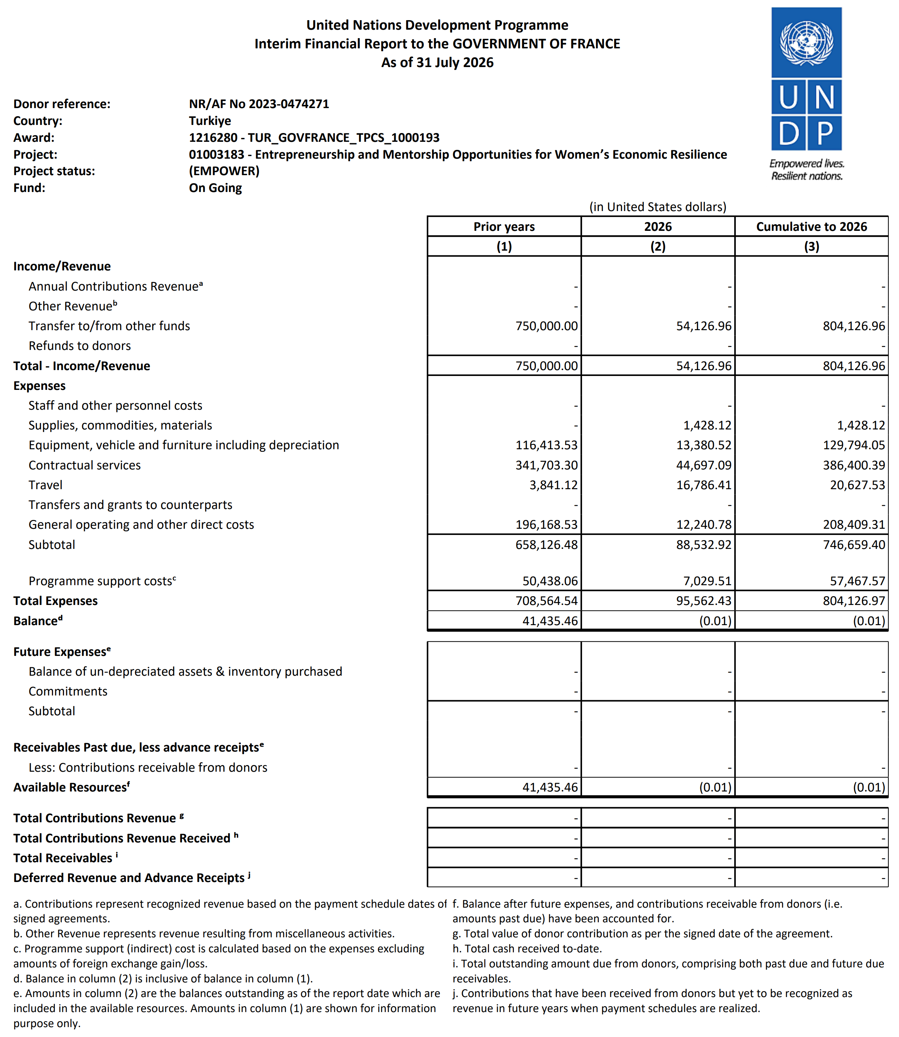
- Annexes
The evidence documents regarding the process of the activities are in the folders linked below.
Annex1: Activity1
Annex2: Activity2
Annex3: Activity3
Annex4: Activity4

